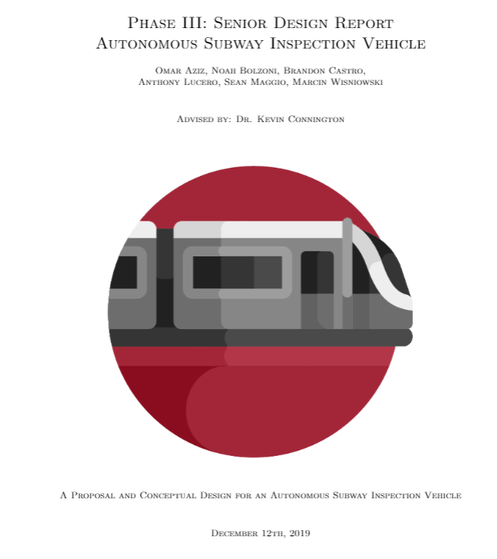

**Project Overview**

The New York City subway is the busiest metro service in the United States. Annual subway ridership in New York City surpassed 1.68 billion in 2018 and daily passengers exceed 5.6 million[1]. Therefore, each issue found on the subway track inevitably leads to the inconvenience and delay of millions of Americans living in New York City. Even with the current advancements in technology and automation, many railway track inspections are conducted regularly by human inspectors. In order to satisfy current regulations prescribed by the Federal Railroad Administration, a mainline track is usually required to undergo a weekly inspection and a geometry car inspection is not considered acceptable for meeting this required inspection frequency[2]. It becomes apparent, therefore, that inspectors are in high demand and yet low in availability.

The Autonomous Subway Inspection Vehicle (subsequently referred to as the ASIV) looks to increase the productivity of subway inspections by uncovering and flagging warnings for track defects early, in order to concentrate a subway inspector’s efforts into distinct geographic areas of focus. While the current regulations may restrict the creation of a fully autonomous system, the project, regardless, adds value by creating an autonomous and live asset management of the subway track. When regulations change in the future, the system can be used to provide stronger analysis for proactive operational investments and scheduling of site-technicians and inspectors for daily maintenance.

**Needs and Specifications**

The proposed design for the track inspection vehicle aims to make mass transit by train more efficient and safe. Current subway transit is constantly plagued by delays and interruptions in service due to issues caused by the track. The MTA uses four large track inspection vehicles to inspect the full length of the track six times a year. This means that there are two months in between inspections on parts of the track. This gap between inspections allows for potential deformation and breakage to go unchecked for up to two months. During this time, the defects could cause derailments and therefore inconvenience the public. The proposed design aims to make more frequent inspections so defects can be identified more often. With more inspections, there will be a reduced number of derailments and inconveniences to the public.

The main customer for the ASIV would be the MTA or Path as they are directly responsible for subway transportation. The MTA/Path requires an inspection vehicle to be able to take reliable measurements, save storage space, and save time. The track inspection vehicles the MTA currently has are full size subway cars that are fitted with sensors and computers monitored by personnel riding inside the train car. For the MTA/Path to increase efficiency, they need a smaller, more cost effective solution. With the ongoing risk of derailments and track deformations, the MTA needs a quicker and cheaper way to inspect the tracks. By building a machine that has accurate sensors, the inspection vehicle will be able to safely determine if a rail is aligned and that the rails are up to code. A smaller autonomous vehicle will save space as well as the cost of personnel to run the vehicle.

The main goal is to create a cheap but effective option to autonomously collect and monitor data on a subway line’s rail. A fully-encompassing system is envisioned for the future, but cannot be done within the given budget and time. Therefore, the current focus is on gathering data for track gauge and staying away from other measurements that may pertain to the rail. If ASIV is accepted as a viable solution, future work may expand on what measurements can be taken or the system may be built modularly to allow for expansion for higher price ranges.

Another aim is to create a system that is non-intrusive to current rail operations and will be able to autonomously remove and place itself onto the rail if objects are identified to be approaching on the rail. Given the regulations change to allow this, the ASIV would be able to effectively live on the track and continuously monitor conditions without intruding on the trains as they passed by.

**Major Issues**

With current research and background in mind, there are two major issues that prove to be the most challenging.

* A lack of external data set to build and test around may stunt design analysis
  + Many inspection services limit the amount of information they share with the public when it comes to technical data and industry-standard tolerances. Currently, the ASIV project relies on thresholds from the Federal Railroad Administration in order to stay within safety thresholds for rail gauge. Ultimately, a rail network becomes very hard to understand how to recreate when these values are not shared. Furthermore, some tests that are needed are very specific to situations that may not have arisen and therefore may not have been tested in similar ways. Some assumptions may need to be made while choosing sensors to allow for new tests to be made. A dialogue with industry employees may need to be constructed to acquire some necessary information.
* It will be challenging to test the system and evaluate whether it fits under industry protocols.
  + It is understood that testing with a trial and error type of approach is not possible in this situation to help hone on specific values as testing on physical track will be limited unless a contact can be found. Instead, reliance should be placed on literature review and current practices for thresholds and sensor data, and reasonable assumptions should be made before testing and making improvements.
  + It is unknown if a company will be willing to supply rail for the purpose of testing. Alternatively, it may be necessary to build a small section of track, with known defects, and test the ASIV across this instead. Nearby areas can also be surveyed to determine if any inactive right-of-ways have useable tracks.
  + Given testing will be difficult to conduct, sensors will need to be bought knowing that it is a likely candidate for use.

**Measurement System**

The tracks have two types of measurements: absolute and relative. The absolute measurements include the position of the rails as a unit to their surroundings and the relative measurements are measurements of the rails relative to each other. ASIV will measure gauge and crosslevel. A document from the Federal Rail Administration from 1979 [8] details a track car which only measures gauge and crosslevel. A paper by a Chinese university [9] research team states that all relevant track geometry can be reconstructed from gauge, crosslevel, and absolute geodesic data. A paper from the FRA [10] which tries to find common statistical variations in track geometry uses only gauge, crosslevel, alignment, and profile. If time permits, ASIV may be outfitted with the ability to measure profile and alignment, but the primary focus will now be on gauge and crosslevel.

In order to do this up to current standards, the Federal Railroad Administration defines several thresholds for railroads to adhere to in their Infrastructure Integrity Compliance Manual[2]. In it, gauge is defined as a measure between the heads of the rails at right angles to the rails in a plane five-eighths of an inch below the top of the rail head. With this definition, sensors can be correctly positioned to measure at the relevant locations of the rail and valid measurements can be submitted into the system. The range of allowable gauge measurements are shown in Table 1 based on track class. The class of a track is related to the speed at which trains will run on it (higher classes sustain higher speeds). The top speed of the MTA subway is listed as 55 mph in Wikipedia, and Class 3 tracks allow commuter trains to run up to 60 mph. This is close to Class 4, and the actual speed the MTA track is capable of is not given, so gauge tolerance will be taken from Class 4. NYCSubway.org says the nominal gauge is 4’ 8.5.” [12]

Table 1: Rail gauge compliance values

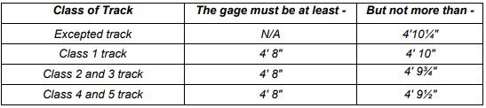

No FRA data for cross level has been found yet, but a track geometry paper for British Standards from 2008 is available [11]. This set of measurement standards does not give a nominal crosslevel, but it does say that crosslevel can be ±225 mm, which equates to about ±8.9 inches.

Also in the British Standards documentation are acceptable resolutions for measurements. These are the resolutions that the measuring equipment must have to be considered adequate for use. For crosslevel and gauge, the resolution must be ≤ 0.5 mm, or ⅕ inch.

**Equipment**

For measuring gauge, ASIV will have two laser distance sensors. They will be mounted on opposite sides of the chassis to measure the distance from the chassis to the left and right rails. Thus, the gauge is found by adding the distance from the left side sensor, the right side sensor, and the distance between the chassis. For testing, we will use a VL6180X Infrared Laser Time of Flight Sensor.

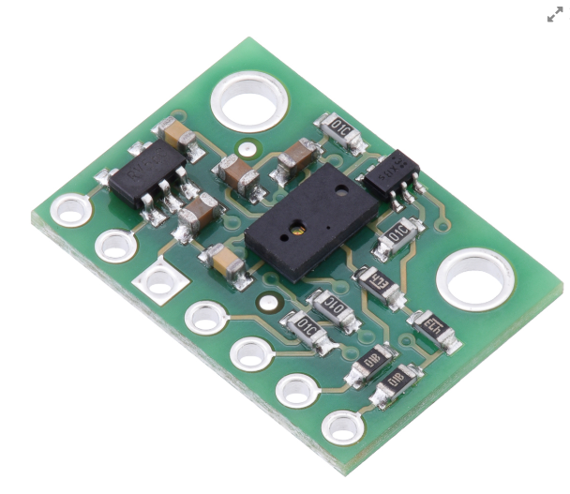

Figure : VL6180X IR Distance Sensor

This is not sufficient for our beta prototype, since it is not accurate enough. The smallest standard deviation of measurement is 2mm, which exceeds the resolution limit shown in the British Standards. This is shown in Table 2. Testing also indicates that it measures at 10 Hz, which is dwarfed by the second measurement candidate.

Table 2: VL6180X Measurement Deviation

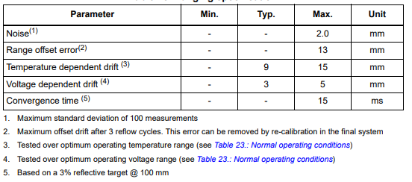

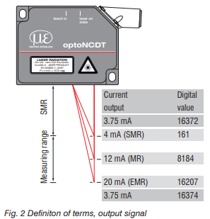

Recently, Micro Epsilon has shipped a donation for two optoNCDT 1402 laser sensors that will be used both in the alpha prototype and the final design. Using laser triangulation, the laser beam can be effectively aligned to give very accurate readings of the track gauge and give back analog responses that can be later parsed into distance measurements. A setting of the sensors allows for accurate output scaling to the desired ranges that can be honed in for the necessary range of values. Accurate alignment and synchronization of the sensors is critical in conveying valuable readings with accurate locations on the rail. The resolution of these sensors is 13-100 micrometers. This is significantly less than the 0.5 mm outlined in the British Standards. The maximum deviation from a linear distance output is less than or equal to 0.36mm, which again demonstrates adequate precision. These will be used in the beta prototype.

An inertial measurement unit (IMU) was also purchased in order to allow for more data to be captured about the current rotation, acceleration, and magnetic measurements from an absolute orientation. In order to keep an accurate reading for gauge the ASIV needs to keep a relative inclination of our sensors to the ground plane and by combining the accelerometer and gyroscope readings found from the IMU that would be possible.

**Evasion Mechanism**

In order to effectively create an autonomous vehicle that can operate on the track, an evasion mechanism needs to exist in order to allow the vehicle to sense when a train, or any object, is incoming and move off of the rail. In order to do this, at such high speeds of travel, the ASIV must be given ample time in order for it to initiate and effectively complete its evasion protocol. Multiple variables were looked at in order to find values that could be used to effectively monitor incoming trains. Audio and visual systems were considered given the loud nature of trains and the brightness of headlights, however both of these were explored to be inconsistent within given situations including at stations with large crowds of people and outside of tunnels. Furthermore, both of these measurements would not be as strong when turning around corners.

An interesting research project was triggered some train collisions with wildlife in rural areas by Jonathan A.J. Backs and his team. As animals are unable to effectively be warned before a train appears, it follows a similar problem that the ASIV faces. Most of the researched systems used a passing relay, which had a sensor placed at a fixed location that could be triggered by a moving train above it, however these were little help to our ASIV robot as it would be constantly moving across the rails to new locations. The group, however, created an approach detector through the use of vibrations and a shielded piezoelectric film to allow for variable distances and give warning before the train was above the detector itself. The evasion mechanism still needs to be explored, however, a vibrational reading appears to be the best way to currently detect an incoming train.

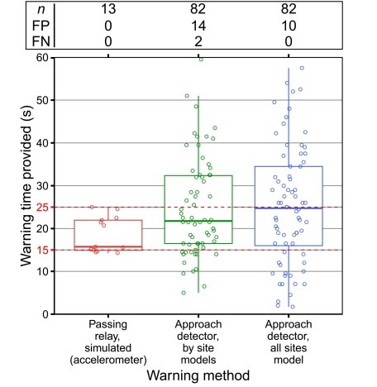

Figure 2: Deviation and mean time provided by detector methods

As seen in Figure 2, while the approach detector is less accurate and prone to error, the research shows that if designed effectively, it is possible to create a sensor that will sense an oncoming train with ample time to react. Further explorations of the use of vibrations to sense incoming trains has led to other reports that state that people living in houses over 60 meters away may sometimes still feel the vibrations of an oncoming train. The strength of vibrations needed in order for humans to be able to sense them is much greater than needed for a piezoelectric to detect and therefore longer waves may propagate specifically through the wave at lower Hertz.

A mechanism will need to be made in order to filter out the noise created by the movement of the ASIV itself, and to only hone in on the range of frequencies that may correlate to trains further distances away. A railway induced vibration report created by the International Union of Railways specifies different frequencies of vibration pertaining to different aspects of the rail[5].

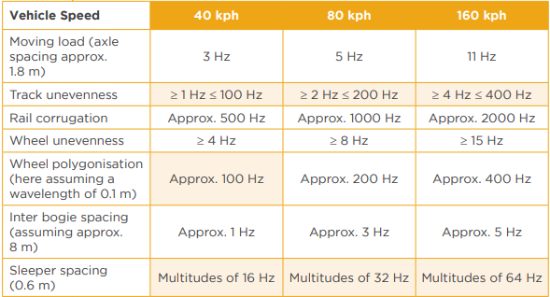

Figure 3: Vibrational frequencies based on speed of vehicle

**Plans for Alpha Versus the Beta Prototype**

It is important for the group to be able to create an alpha prototype to accurate measure and begin to test the sensors and motor currently purchased to make sure that they adhere to the calculations made. CAD drawings have been made for the alpha prototype and many of the materials have already been purchased. As permission for testing on actual rail tracks is still not granted, for the purposes of the alpha prototype, 2x4 wooden beams are planned to be used as a substitute. These will allow a strong simulation of the rail and can be easily altered to create situations where the sensors should measure issues in the gauge.

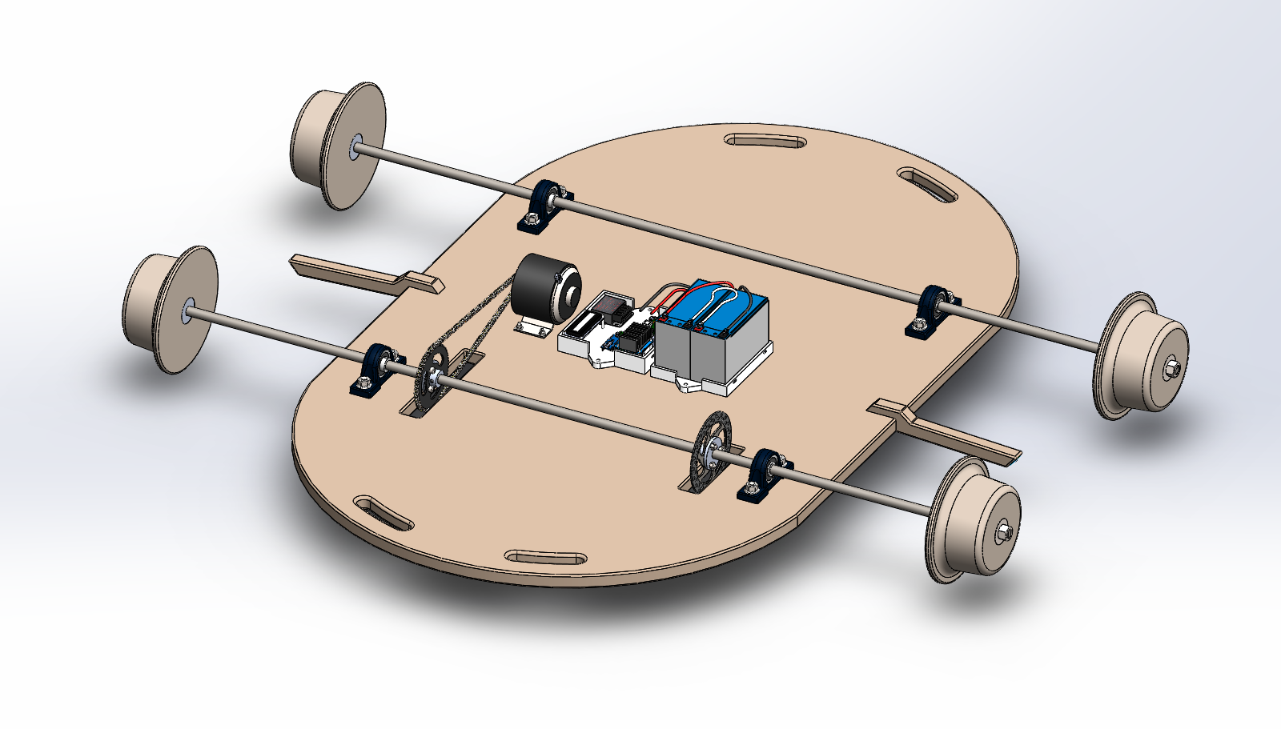

Figure 4: Current Alpha Design CAD Drawing

Shown above in Figure 3 is the updated alpha prototype. The prototype is built around a heavy and narrow wooden base to emulate the weight and dimensions of the proposed beta vehicle and chassis shape. The prototype consists of two fixed axles, with one being driven using a chain-drive system connected to a single motor. The driven/live axle has two key differences from the dead/beam axle, which are two attached components - a sprocket and disk brake. The sprocket is used to connect to the chain to transmit power from the motor. The disk brake is added in case testing reveals that motor braking is not enough to stop the vehicle in adequate time and distance.

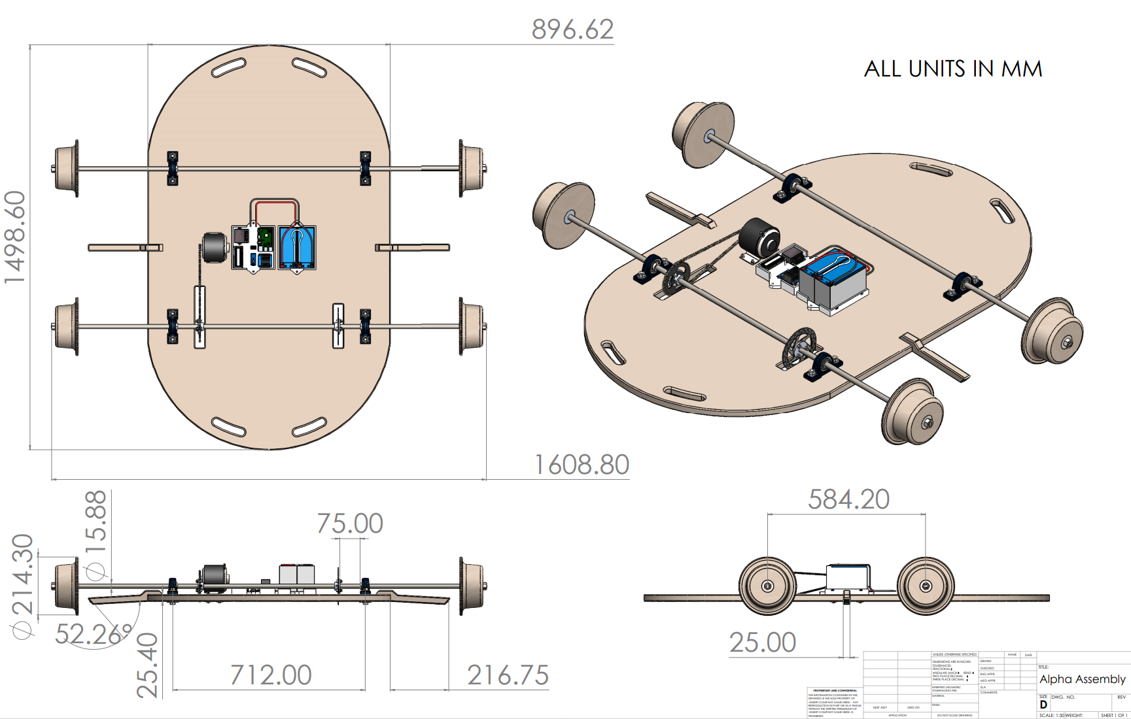

Figure 6: Sprocket and Disk Brake Hubs

Shown in the technical drawing above are major vehicle dimensions. The overall profile of the vehicle is 1.6m wide by 1.5m long, and a height of 214mm derived fully from the wheel flange diameter.

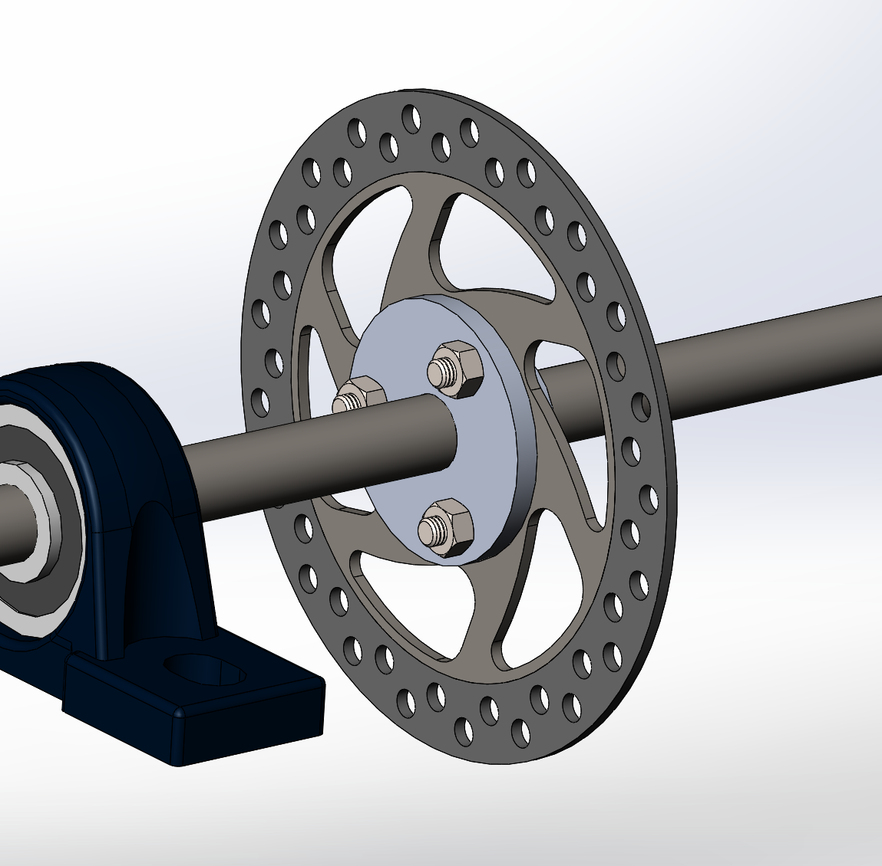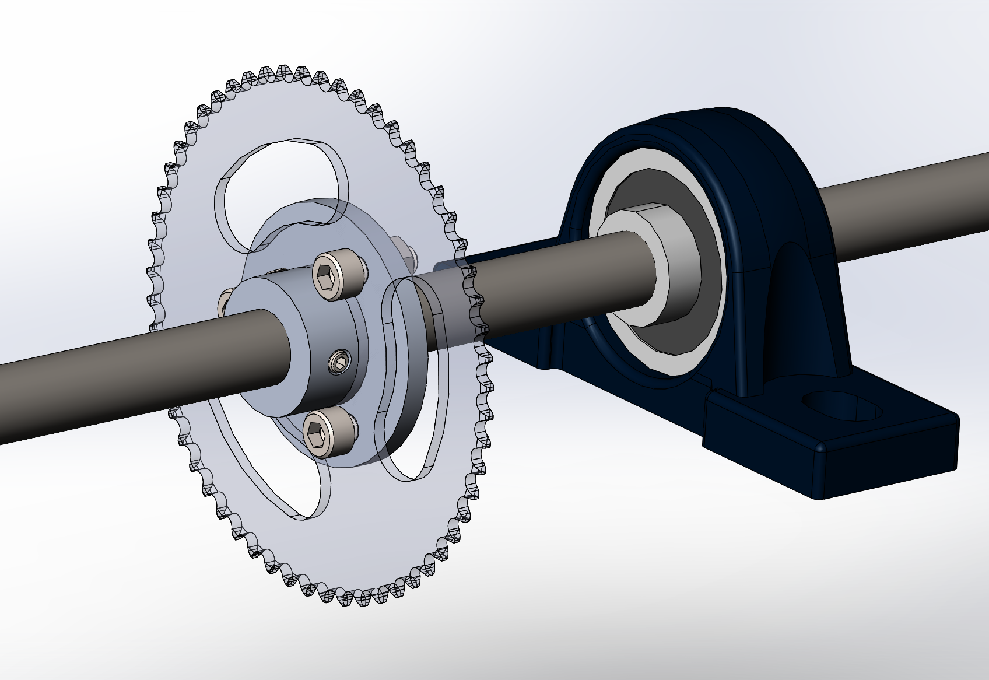

Figure 7: Sprocket and Disk Brake Hubs

The sprocket and hub are attached to the axle via a custom machined aluminum hub with two set-screw holes over flat spots on the axle. Analysis of the torque requirements for a single motor, detailed later in the paper, show that around 4.5 N-m, or ~40 lb-in is required to move the 40kg vehicle. Shown in the figure below are various set-screw sizes and their respective torsional holding power.

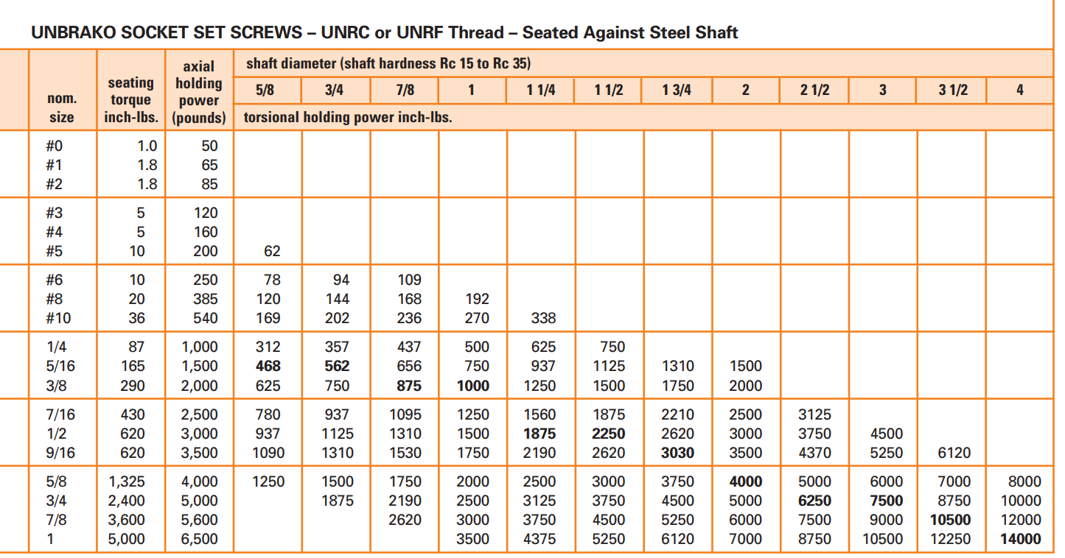

Figure 8: Set Screw Holding Power Chart [6]

Two #10 set-screws are used per hub in the current design. This results in 169 lb-in of torsional holding power for one screw for the ⅝ in shaft used in the alpha prototype. This confirms that the design is valid and has a high factor of safety.

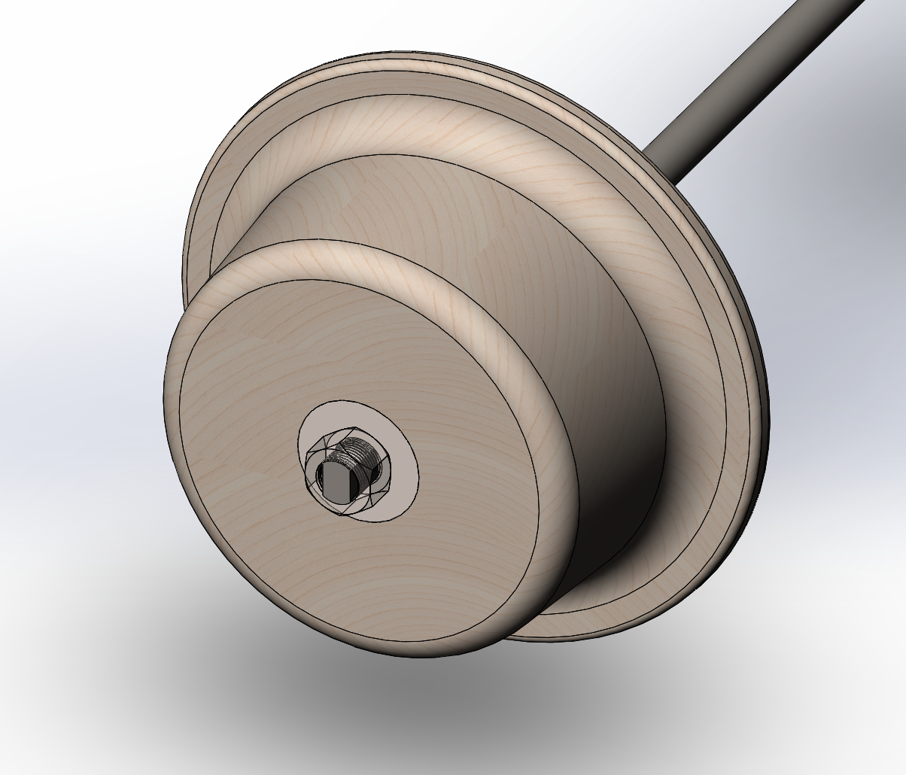

Figure 8: Wheel Design

The wheels are constructed and machined from five plywood sheets of ¾ in. thickness stacked and glued together. The flange is around 214 mm in diameter, while the wheel itself is a minimum of 150mm in diameter. A 5 degree taper is used to give the wheels a conical shape, which allows track vehicles to be inherently stable and self centering, especially around curves.

The wheel revolve profile is shown in Figure 9 below.

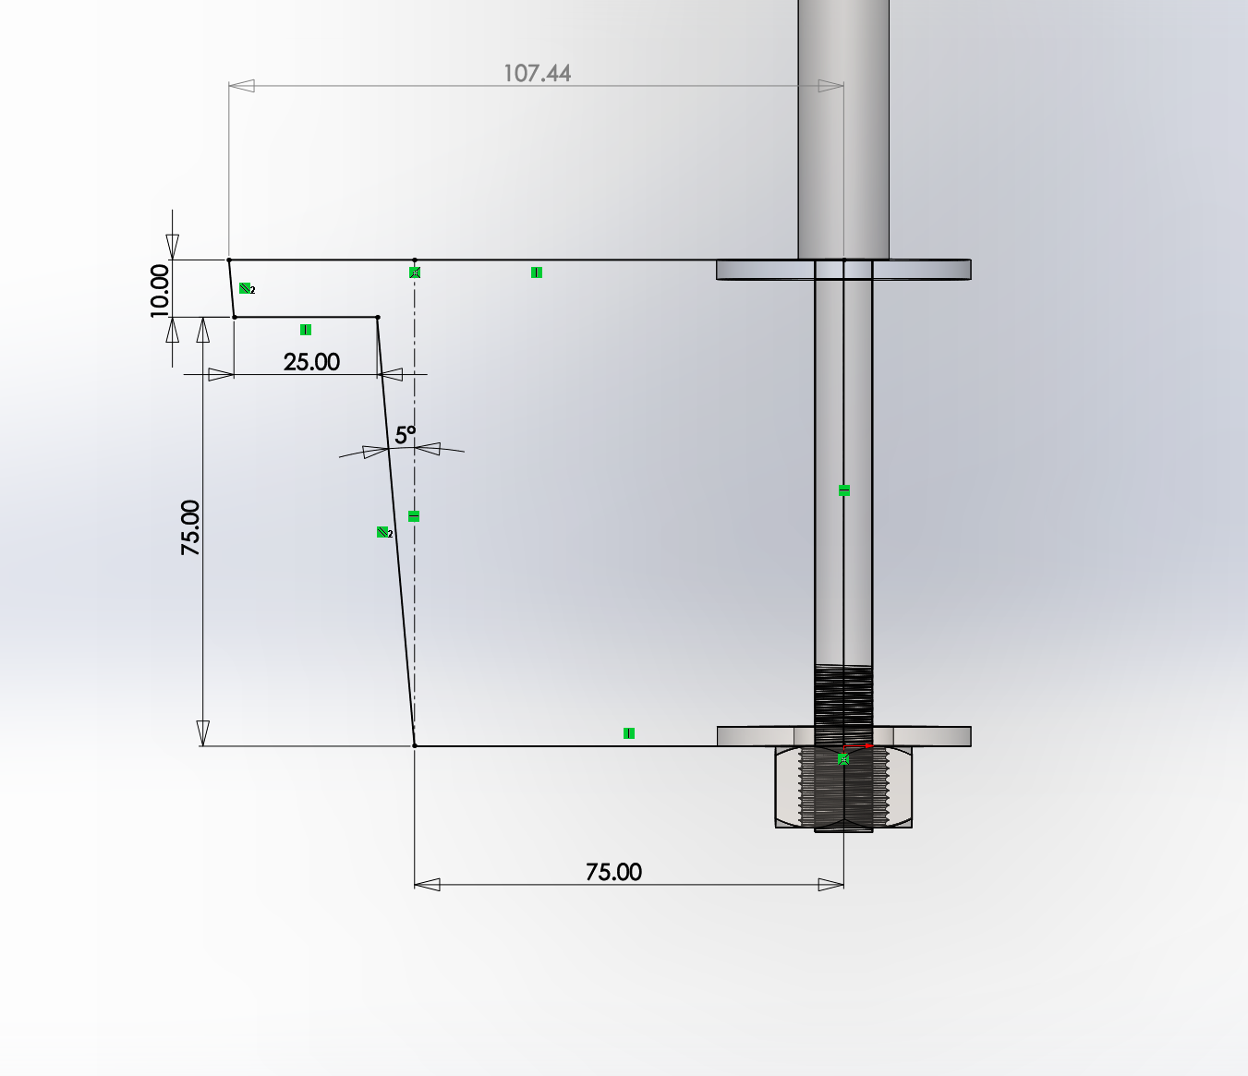

Figure 9: Revolve Sketch Profile

The wheels are attached to the axle via two machined flat surfaces on the axle. The ends of the axle are threaded to allow a hex nut to secure the wheel in place so it does not translate axially. This is detailed below in Figure 10.

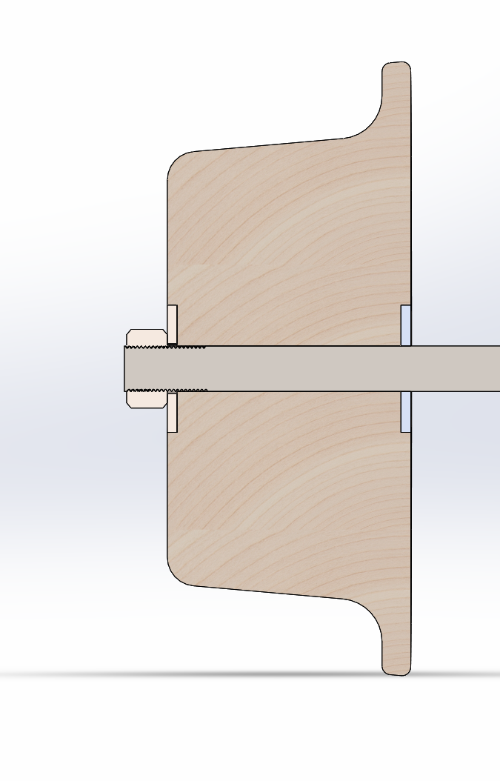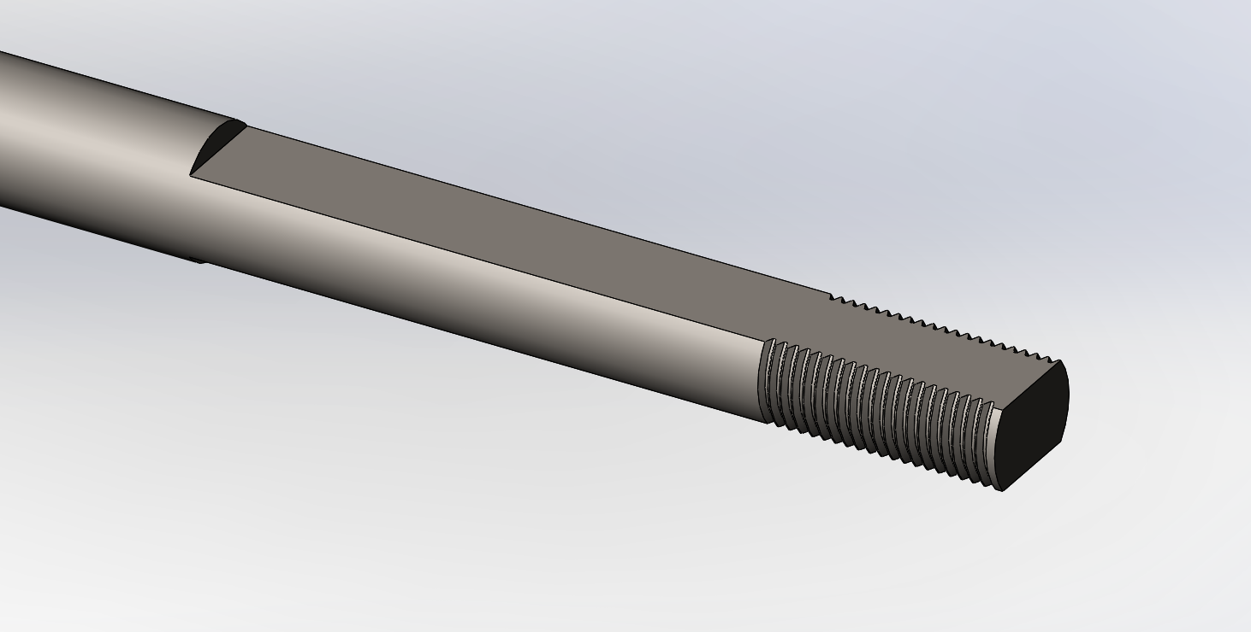

Figure 10: Wheel Internal Section and Axle End

To distribute the weight evenly between the wheels, all major components that are not attached to the axles (such as the batteries, motors, and control box) are placed equidistantly between the two axles, where they can then be translated left or right to align the center of mass with the dimensional center of the overall vehicle. This is shown in the top view below.

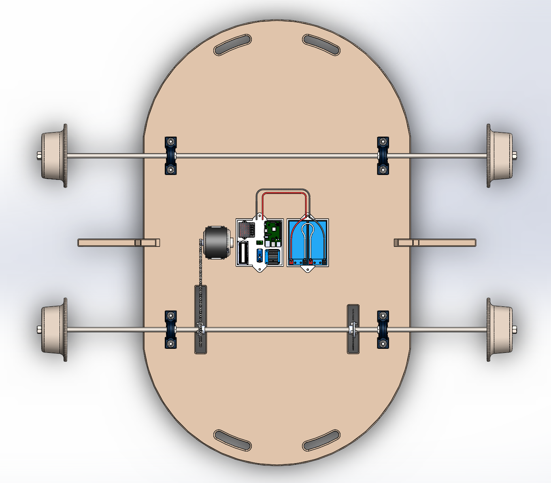

Figure 11: Top View

The batteries, motors, and control box are shown in greater detail in the close up in Figure 12 below. The motor is on the left, the control box is in the center, and the two batteries are placed on the right. In the control box there are several components for controlling the vehicle. Centered is an inertial measurement unit for collecting acceleration and gyroscope data about the vehicle’s orientation, heading, and motion. In the top left is a step down converter to convert the 24V battery input to 5V to power the Raspberry Pi and Arduino Nano, also pictured to the right and bottom of the inertial measurement unit, respectively. In the bottom left is an LCD screen for displaying critical data such as battery voltage and vehicle state. In the bottom right is a motor driver for controlling the motor by input from the Arduino Nano.

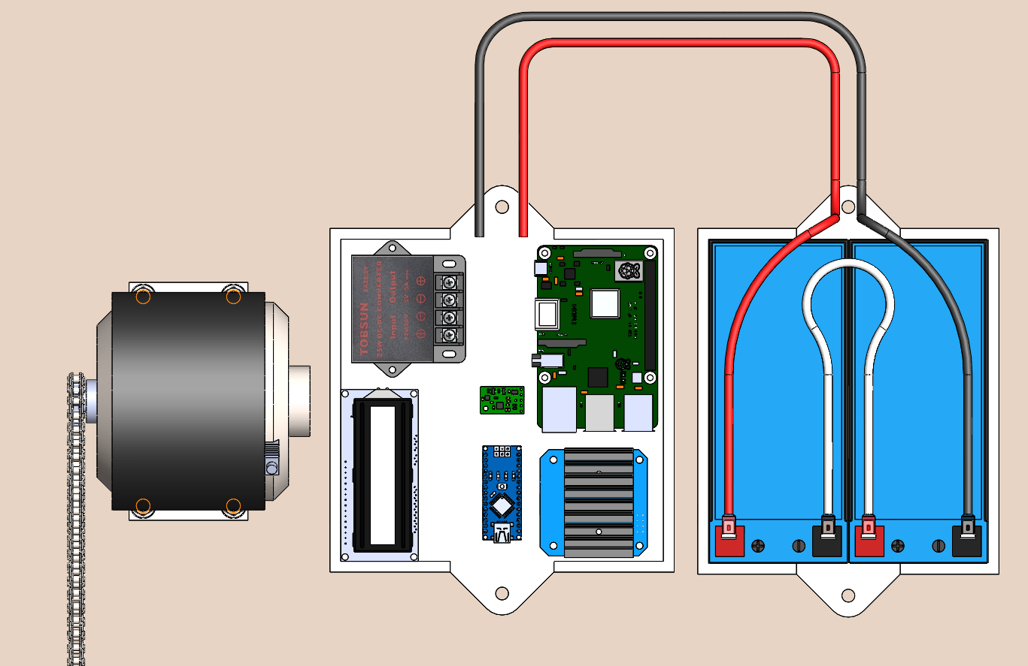

Figure 12: Close up of electronics

**Control System**

Asynchronous sampling with slave arduino controllers and a future synchronization through a Raspberry Pi master controller is the system that is being explored currently. Ultimately, due to the expensive sensors that were donated, the ASIV will look to gather as many data points as possible from both the left and right rails and send them off to the Raspberry PI. Here, they will be combined together into a more coherent package with a time stamp and odometer reading in correctly map the values to the rail network. The results of that test will dictate whether the group moves forward with that design or pivots to a more synchronous and trigger based sampling system. This type of control system would limit the amount of readings to a set amount per time interval but would be easier to organize in a synchronous package between both sides. It is beneficial to try and get the most readings out of these sensors before limiting them with a timed trigger system.

The major control tasks are outlined here:

Requirements –

* Read distance from robot body to left rail
* Read distance from robot body to right rail
* Sum these distances to give rail width (known as gauge)
* Give tilt of vehicle
* Give location of robot using odometer
* Control velocity with feedback loop
* When a measurement is taken, it should be connected to a distance measurement (so
* when a value is read to be out of specified tolerance, the location of said defect is known)

Operation –

* Give live measurement “package” (angle, gauge, location)
* Store measurement “package” to be read with Excel
* Set velocity

The overall architecture is shown in Figure 13. An arduino reads distance and angle measurements. A second arduino controls velocity and a velocity feedback loop. Sensor data is given to the Raspberry PI, which gives a live readout of data on a screen, and may send data to a laptop via Wi-Fi. Data is recorded locally on an SD card. The Arduino loop will likely be fast enough to give all measurements in such a small time interval, they can be considered taken at the same point on the track. If not, further research will be done to sync data. The feedback/velocity loop is isolated from the measurement Arduino to allow the measurement Arduino to pick up measurements as quickly as possible. Odometer calculations will either be done on the velocity Arduino or Raspberry Pi, but could be done on the measurement Arduino if it does not hinder measurement speed. Measurements entering the Raspberry Pi are time stamped as a group with the Raspberry Pi’s clock reading, and the Pi also turns on and off subsystem Arduinos.

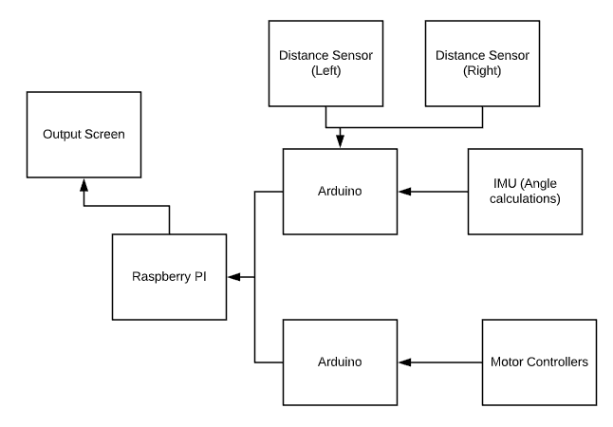

Figure 13: Control System Flowchart

**Specifications from Initial Design**

The following dimensions and mass properties were taken from the initial CAD model in Solidworks for use in kinematic calculations.

Table 3: Specifications from Initial Design

|  |  |  |
| --- | --- | --- |
| **Initial Specification** | **Value** | **Comments** |
| Total Mass | 40 kg |  |
| Individual Wheel Mass | 1.17 kg |  |
| Projected Area for Front | 0.3 m2 |  |
| Nominal Wheel Diameter | 0.15 m | 5.9 inches |
| Drag Coefficient | 1.0 | Cubic approximation |
| Braking Radius |  |  |

**Motor Power**

Before a motor could be selected to power the vehicle, calculations were performed to approximate the applied resistance to its motion. A free body diagram was drawn to demonstrate these forces on level track. In this case, the approximation of level track is used since the vertical displacement the vehicle would continually vary from aiding motion to retarding it over the length of the route depending on the direction of travel. Thus, the overall effect of inclines was assumed to be null. Additionally, since a gradual acceleration profile was assumed in any case, the forces were only examined to maintain a constant target speed. Tests and further analysis will be performed on the alpha prototype to verify that the motors can maintain a reasonable acceleration rate from standstill when also subjected to a positive (uphill) incline.

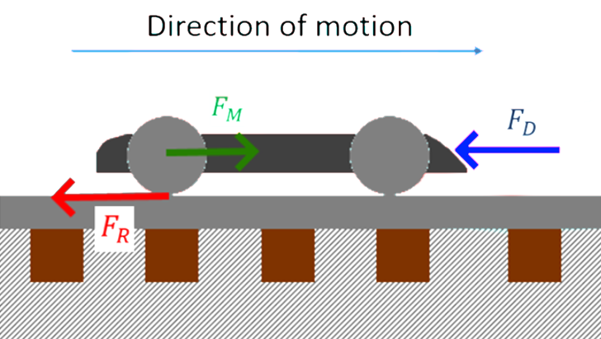

*Figure 14. Free body diagram of forces relevant to motion on level track.*

In the figure above, FR represents the force of rolling resistance at the contact patch of each wheel, FD represents the force of drag normal to the front area of the vehicle, and FM represents the input force of the motors driving the vehicle. When the vehicle is travelling at a constant velocity, these forces will be in equilibrium.

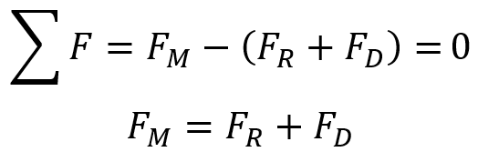

The forces of rolling resistance and drag are further defined into their respective terms as follows,

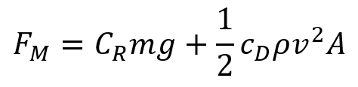

In this case, rolling resistance includes a coefficient of rolling resistance and the weight of the vehicle while the drag term includes a drag coefficient, the density of air, the velocity of the vehicle, and the frontal surface area of the vehicle. Plugging in specified values for the prototype yields the following braking force,

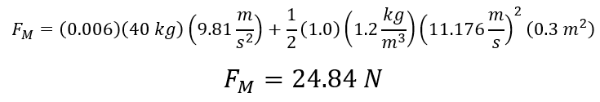

The coefficient of rolling resistance for wood wheels on steel rails was estimated as 0.006 with the given wheel radius of 0.18 m, while the fluid density was taken to be approximately 1.2 kg/m3 for air at standard conditions. This motor force can be converted to the required power output using the following formula,

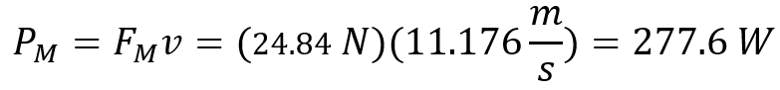

This value is useful for determining a reasonable dc motor to use with the vehicle as most commercial models provide a rated power in watts. Given that the alpha prototype single motor is rated at 400 watts, this is a reasonable starting point to start testing the performance and actual power draw for the vehicle.

Selected specifications for said motor are shown below:

Table 4: Motor Specifications

|  |  |
| --- | --- |
| **Specification** | **Value** |
| Rated Voltage | 24 V |
| No Load Speed | 2400 rpm |
| Rated Torque | 0.93 N-m |
| No Load Current | 2.0 A |

This information can be used to find the motor voltage constant *ke*

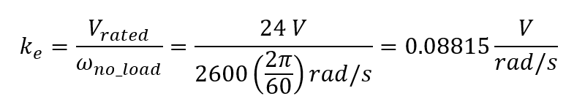

When using SI units, one can extrapolate that this constant *ke* is equal to *kT* which is the motor torque constant whose units are those of torque over current. Thus,

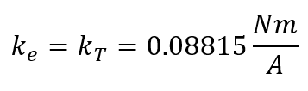

The usefulness of these constants is shown in the next section when current drawn from the battery must be considered.

**Current Drawn from Battery**

Given that the force to maintain a constant speed of 25 mph is approximately 25 Newtons, this force can be converted to an equivalent torque at the driving wheels of the vehicle given the definition of torque as a force multiplied by a radius.



With this in mind, it is now possible to use the motor torque constant to approximate the current to the motor in this instance.

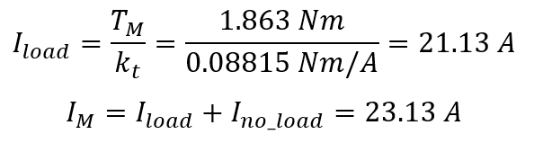

**Braking Forces**

The max force that can be applied to brake a vehicle depends on its weight and its level of adhesion to the rail. The relationship can be expressed as the following,

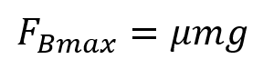

In this case μ refers to the adhesion coefficient between the wheel and rail. Assuming a steel-on-steel interface, the coefficient can vary from a value as low as 0.05 to as high as 0.7 depending on factors such as presence of water, grease, or oil on the track and other contaminants that can either aid or inhibit interfacing between the wheel and rail[3]. A moderate value of 0.4 was chosen for this analysis since this value reasonably encapsulates what might be experienced in a relatively a tunneled setting that is relatively shielded from precipitation, leaves, etc. Given that the alpha prototype will use wooden wheels, this value is a reasonable assumption given the similar range for wood on metal (0.2 - 0.6).

**Engineering Design**

The autonomous subway inspection vehicle is aimed towards measuring track gauge and allowing for more frequent inspections of the subway tracks all year round. By providing a cheaper and more efficient way to ensure that the tracks are aligned, it will allow for a safer environment within the subway tunnel system as the ASIV unit will assist in decreasing the rate and frequency of derailments. Having a fully autonomous design will also decrease the need for workers on subway tracks which increases the level of safety for workers in the subway system. Previous methods of track maintenance involved workers walking through the tunnels inspecting the tracks with just a flashlight and hammer which posed safety issues as well as train delays. The design for the ASIV unit will help to mitigate these dangers by quickly and accurately measuring the quality of the rails. The ASIV will also incorporate an evasion mechanism to account for the case of trains or obstacles on the path to ensure that no further damage is created. This project will also benefit the millions of people that use the subway everyday as its ulterior motives are to decrease train delays and provide a safer environment for everyday use.

The final design for the vehicle utilizes MTA standards to ensure that there are no rules or code that are not being upheld. The height of the vehicle is in compliance with MTA standards so that there is no interference with any objects underneath the line of collision. As depicted by NYCT MW-2, the bottom of all subway trains must be created at a set clearance line of 2.5 inches above the plane of the top of the rails. The ASIV unit will also use the MTA track standards for the distance between each track so that the sensors can measure if the track gauge is at the 4’ 8.5” in” that is required.

The vehicle utilizes various ANSI Inch and Metric standards in all of the hole, thread, bolt, nut, and washer sizes. This ensures no large amount of parts have to be custom made to produce the vehicle.

**Project Plan**

**Deliverables**

*Table 5: Deliverables for Next Phase*

|  |  |
| --- | --- |
| **Deliverable** | **Description** |
| Alpha Prototype for ASIV | A physical model of the vehicle will be created to measure select values of the final design. Sensors and controllers have been procured, but drive train parts must still be purchased. The code must be created to allow the system to measure the different variables. |
| Procurement of Testing Location | A testing location must be found to host prototype for accurate testing and analysis. Alpha prototype testing location can be anywhere, but Beta Prototype must be on rails to prove that the system can measure track gauge accurately. |
| Defect Testing and Overall Functionality Tests | Tests will be performed to gauge the effectiveness of the selected sensors and controllers to ensure that the system is functioning properly. The motors and braking components of the design must also be tested. |
| Analysis and Recommendation | After initial defect and functionality testing, an in-depth analysis will be taken to provide recommendations for the future design. |

After completing the technical analysis of the design as well as selecting the final concept for the project, a preliminary list of parts was created for purchase. The table below shows an up-to-date budget with the materials bought as well as the estimated budget remaining for the rest of the design.

*Table 6: Up-to-date Budget*

|  |  |
| --- | --- |
| **Up-to-Date Budget** | |
| **Purchased Sensors** | |
| **Item** | **Price** |
| Laser Sensors | Donation from Micro-Epsilon |
| Gyro & Accelerometer Unit | $15.95 |
| IR Time-of-Flight Sensor (x3) | $25.47 |
| **Purchased Parts** | |
| **Item** | **Price** |
| SS 304 ⅝” Rod (x2) | $26.50 |
| Pillow Block Bearings (x4) | $22.58 |
| 12 V 7AH SLA Battery (x2) | $34.40 |
| 12 V Battery Charger | $9.99 |
| **Total Cost:** | $134.89 |
| **Remaining Budget:** | **$565.11** |

Figure 15 below illustrates the designated tasks that need to be met for the completion of the project. This is the overall Gantt Chart to show which tasks have been completed and which tasks need to be completed with the milestones and critical path outlined below. Any revisions to the tasks or the timing will be reflected as updates in the Gantt Chart.

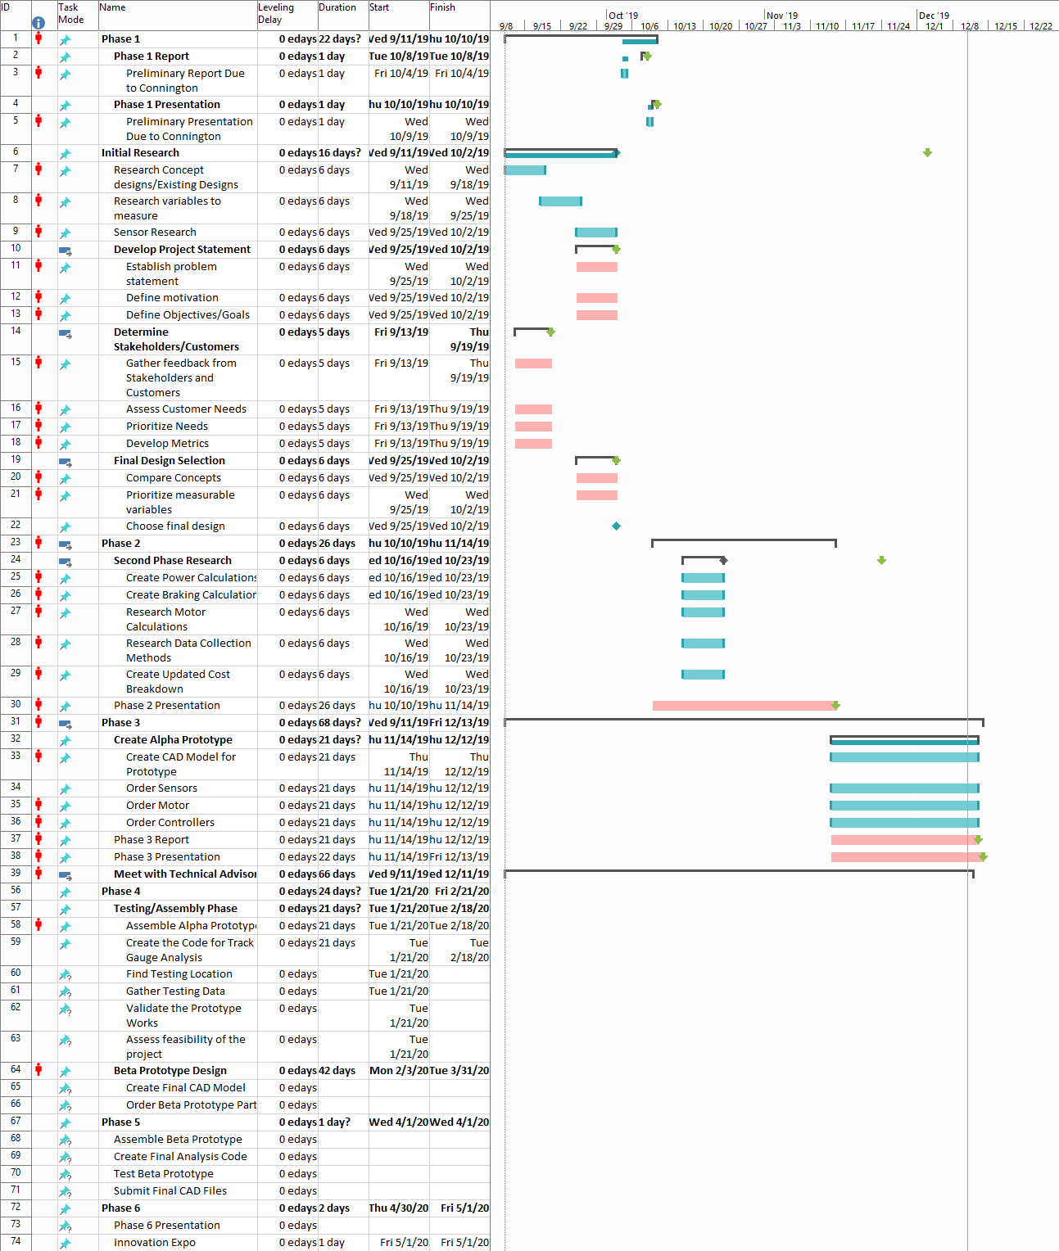

*Figure 15: Complete Gantt Chart*

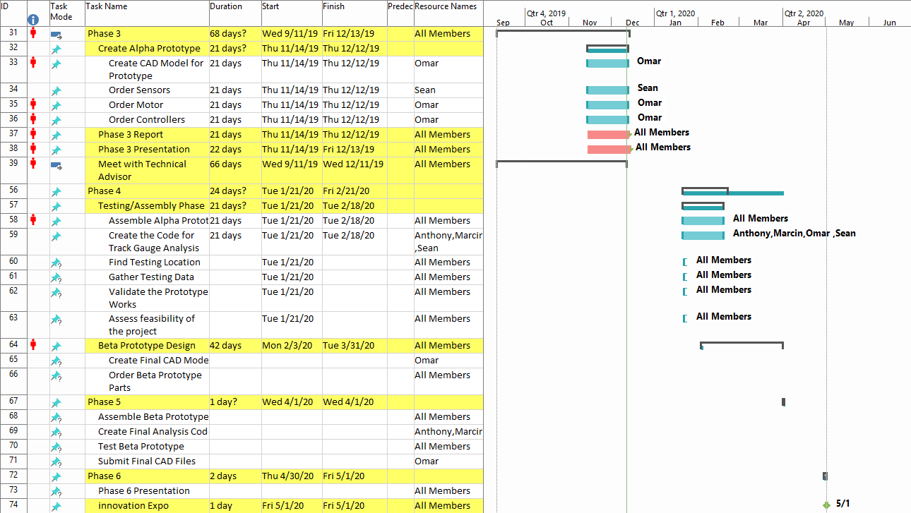

*Figure 16: Phase III to Phase VI Chart*

The above chart gives a closer look at the tasks that need to be completed for the future. Once future dates are given, the Gantt Chart will be updated to reflect those specific due dates, but this Figure demonstrates that progress will be taken after the break.

**References**

1. Metropolitan Transportation Authority (2018). MTA annual subway ridership facts and figures.
2. Federal Railroad Administration (2017). Track and rail and infrastructure integrity compliance manual.
3. Magel, E. E. (2017). A Survey of Wheel/Rail Friction (OMB No. 0704-0188). Washington, DC: Office of Research, Development and Technology.
4. Backs, J.a.j., et al. “Warning Systems Triggered by Trains Could Reduce Collisions with Wildlife.” *Ecological Engineering*, vol. 106, 2017, pp. 563–569., doi:10.1016/j.ecoleng.2017.06.024.
5. de Vos, Paul. *Railway Induced Vibration - State of the Art Report*. UIC-ETF (Railway Technical Publications), Nov. 2017, uic.org/IMG/pdf/vibration_report_v2.pdf.
6. “Torisional and Axial Holding Power.” Eastern Creek, Australia, 22 Apr. 2016. <https://www.hobson.com.au/files/technical/utd-sg-i-hold-power.pdf>
7. “Notice of Addendum: Addendum #19.” MTA - New York City Transit, New York, NY, 2019 <http://web.mta.info/nyct/procure/addenda/200808add19.pdf>
8. M. A. Sherfy, *TRACK GEOMETRY MEASUREMENT BY HIGH-RAIL VEHICLES*, NOVEMBER 1979 FINAL REPORT, U.S. DEPARTMENT OF TRANSPORTATION FEDERAL RAILROAD ADMINISTRATION OFFICE OF RESEARCH AND DEVELOPMENT Washington, D.C. 20590, Nov 1979
9. Qijin Chen, Xiaoji Niu, Lili Zuo, Tisheng Zhang, Fuqin Xiao, Yi Liu and Jingnan Liu, *A Railway Track Geometry Measuring Trolley System Based on Aided INS*, Published in MDPI, Switzerland, 10 Feb 2018
10. John C. Corbin, STATISTICAL REPRESENTATIONS OF TRACK GEOMETRY VOLUME I-TEXT, u.s. DEPARTMENT OF TRANSPORTATION FEDERAL RAILROAD ADMINISTRATION Office of Research and. Development Washington, D.C.
11. Railway applications — Track — Track geometry quality — Part 1: Characterisation of track geometry, BRITISH STANDARD, BS EN 13848-1:2003 +A1:2008, 30 September 2008
12. Facts and Figures. Subway FAQ. <https://www.nycsubway.org/wiki/Subway_FAQ:_Facts_and_Figures>